**VOCATIONAL TRAINING HUB APPLICATION-PROJECT**

1. Introduction

The "Vocational Training Hub" is a desktop application developed using Java Swing. It is designed to provide users with an interactive interface to explore tutorials for vocational skills such as tailoring, carpentry, and electronics. The application employs a Card Layout to seamlessly navigate between different panels, each representing a skill-specific tutorial.

2. Features Implemented

**1. User Interface (UI):**

* Utilized Java Swing components for an intuitive and visually appealing interface.
* Includes a menu bar for easy navigation.
* A home panel with buttons for selecting specific tutorials.

**2. Menu Bar:**

* **Home**: Navigates back to the home screen.
* **Exit**: Closes the application.

**3. Card Layout Navigation**:

* Each panel represents a specific tutorial.
* Users can switch between the home panel and the tutorial panels.

**4. Tutorial Panels:**

* Each tutorial panel displays a title and a description.
* Scrollable text area for better readability of descriptions.

**5. Responsive Design:**

* Proper use of layout managers like Grid Layout and Border Layout ensures a structured interface.

**6. Cross-platform Compatibility:**

* Runs on any system with Java installed.

3. Screenshots of the Project Interface

**1 .Home Panel:**

* Contains buttons to access "Tailoring Tutorials," "Carpentry Tutorials," and "Electronics Tutorials."
* Buttons are arranged in a grid layout for simplicity.

(Include a screenshot of the home panel here)

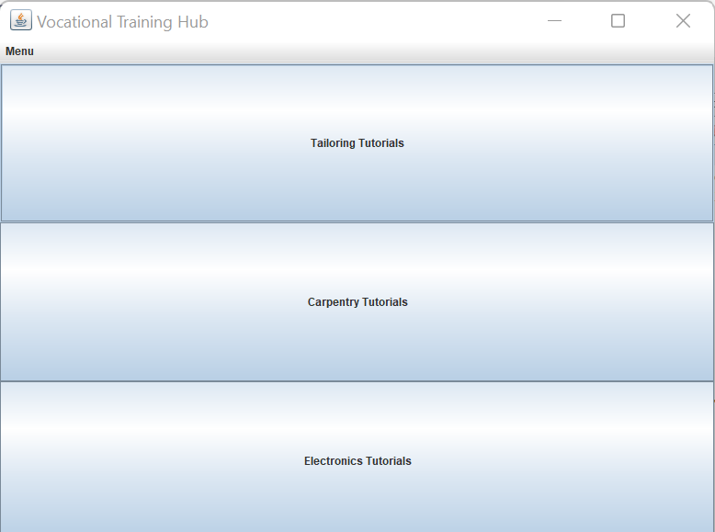

**2. Tailoring Tutorials Panel:**

* Displays the title "Tailoring Tutorials" and a brief description of the content.
* Includes a scrollable area for longer text.

(Include a screenshot of the tailoring tutorials panel here)

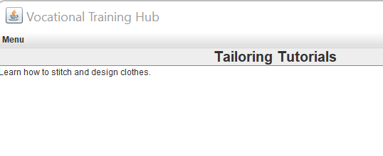

**3. Carpentry Tutorials Panel**:

* Similar design to the tailoring panel with the title "Carpentry Tutorials" and its description.
* (Include a screenshot of the carpentry tutorials panel here)

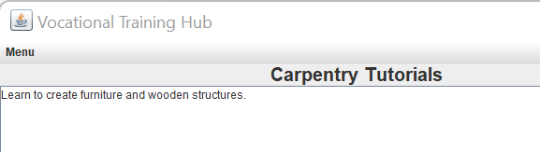

**4. Electronics Tutorials Panel:**

Displays the title "Electronics Tutorials" with an explanation of the skills offered.

(Include a screenshot of the electronics tutorials panel here)

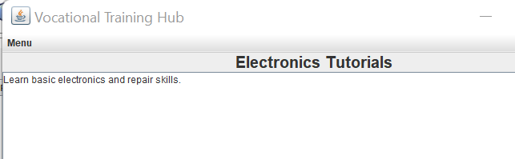

4. Challenges Faced

1**. Card Layout Implementation**:

* Initially, understanding how Card Layout works and how to properly switch between panels was challenging.
* Solution: Thoroughly reviewed documentation and experimented with small examples.

2**. Text Wrapping in Tutorial Descriptions**:

* Ensuring the text descriptions were readable without overflowing required careful setup of the J Text Area component.
* Solution: Enabled line wrapping and added a scroll pane for better user experience.

**3. Menu Bar Integration:**

* Proper integration of Minibar with action listeners for seamless navigation.
* Solution: Tested different layouts to ensure compatibility with the main panel.

**4. UI Responsiveness**:

* Maintaining consistent appearance across varying screen sizes.
* Solution: Used layout managers effectively and tested on different resolutions.

**5. Conclusion**

The Vocational Training Hub successfully demonstrates a functional desktop application with intuitive navigation and modular design. It provides users with a centralized platform to explore tutorials for different vocational skills. This project showcases the potential of Java Swing for building educational tools.